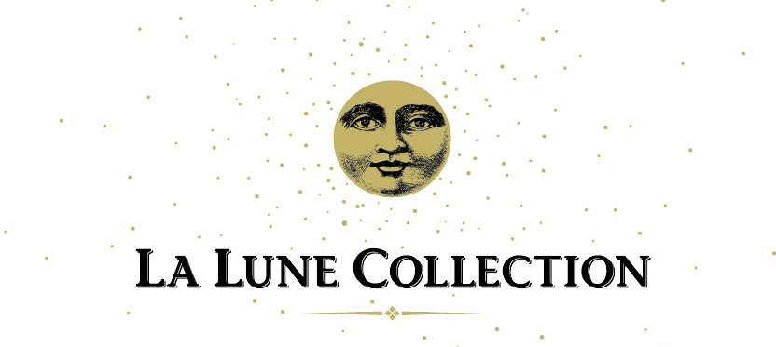
Who is La Lune Collection?
La Lune Collection is a small company that specializes in the design and manufacture of high-end, handcrafted rustic furniture; it was founded over 40 years ago by Cathy and Mario Costantini after years of running their namesake interior design firm in downtown Milwaukee. Situated in Milwaukee’s East Side/Riverwest neighborhood in lovingly restored cream city brick factory buildings dating back to the early 1900’s, La Lune enjoys a national profile in the interior design industry – loyal clients include Ralph Lauren, Disney Resorts, and Ritz Carlton hotels.
What company position is available?
La Lune Collection seeks a Sales + Operations Manager – this person will oversee and implement procedures that revolve around sales and the order process, including, but not limited to:
- Manage the processing and execution of all orders and sales in a timely manner
- Handle requests for quotes and information from existing and potential clients
- Maintain communication between company departments and managers
- Participate in marketing projects and initiatives relative to the company’s online presence
Who is the ideal candidate for the position?
Applicants should have experience or strong interest in the interior design industry and/or furniture business. La Lune will train, however, the ideal person for this position would exhibit the following:
- Enjoy communicating and working with interior designers, suppliers, and other diverse members of the industry community
- Have a passion for furniture, design, and people
- Exhibit an attention to and appreciation for detail, as well as solid organizational aptitude
- Display patience and a positive attitude
- Show strong listening and communication skills
- Demonstrate integrity and loyalty
- Provide a positive leadership model for all employees
- Appreciate the company of dogs
Any additional information?
La Lune Collection is located at 930 E. Burleigh Street, Milwaukee WI 53212 (414) 263-5300
Website: www.lalunecollection.com
Parties interested in applying for the position are invited to send their resume and letter of interest to Cathy Costantini at cathy@lalunecollection. Salary and benefits, which will be commensurate with experience and education, will be discussed at the time of interview.

