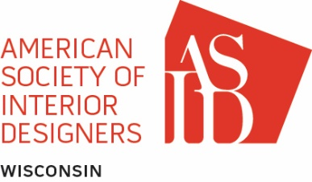

**ASID STUDENT REPRESENTATIVE TO THE BOARD (SRB) JOB DESCRIPTION**

**Student Member Representation**

If a chapter includes one or more student chapters in its geographic territory, the board of directors shall include as a voting member thereof, a student member, selected by the board to such position for a single one-year term, from among qualified candidates nominated by student chapter presidents, faculty advisors or chapter board members. Qualifying students may also independently submit applications to the board of directors for consideration in the SRB pool. In order to qualify for such board position, the nominee or applicant must be 1) a member of a student chapter operating in the chapter’s geographic area and 2) entering an advanced level of their program at the time of nomination. The SRB shall be selected by the seated chapter board of directors during the dates that coincide with the chapter board elections no later than March 30 of each year, to begin serving on the board beginning October 1, ending September 30.

**The SRB is responsible for representing all student chapters and student members at large within the chapter and**

* Attends ASID Leadership Training Program web events for the SRB position, as well as chapter-hosted leadership training
* Attends all professional chapter board meetings as a voting member and acts professionally and responsibly as an active board member
* Serves as the liaison between the professional chapter, student chapters, and student membership at-large and communicates regularly with all parties
* Writes a brief report for each board meeting, reporting students’ concerns and achievements at chapter board meetings
* Visit all design programs in the chapter at least once during the school year (if possible)
* Communicates with the national ASID Student Advisory Council (SAC)
* Encourages student participation in ASID programs which are offered on both national and chapter levels
* Assists in coordinating and promoting chapter sponsored student programs and events such as Career Day
* Orients successor SRB
* Encourage student participation on all chapter committees