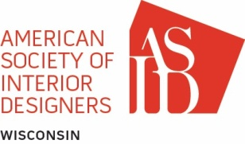

THE WISCONSIN CHAPTER OF ASID
BOARD MEETING MINUTES

Meeting Date: April 11, 2018
location | Telephone Conference Call
board members present | Ariel Steuer, Bill Beaudreau, Molly Hooper, Sondra Pace, Katie Edwards, Michelle Kempen, Jordan Green
meeting called by | Ariel Steuer
call to order | 12:05 pm
AGENDA TOPICS

STUDENT REPRESENTATIVE TO THE bOARD NOMINATION
MOTION | Sondra Pace – Motion to approve Sarah Hansen – UW-Stevens Point as the next SRB for the chapter for FY 2019.
SECONDED | Molly Hooper.
DISCUSSION | - Ariel will send congratulatory letter to Sarah Hansen and cc Sondra Pace and Jordan Green. Sarah Hansen will be integrated into board communications prior to the start of the position on October 1, 2018.
VOTE | Approved.

NOMINATION COMMITTEE SLATE FOR NEW BOARD MEMBERS
MOTION | Michelle Kempen – Motion to accept and approve the Nomination Committee’s slate for President-Elect (Teresa Olson); Director at Large (Bridgett Fish); and Membership (Jennifer Hunt).
SECONDED | Katie Edwards.
DISCUSSION | Information binders are being created for the board positions of Membership and Director at Large to pass on during the transition
VOTE | Approved.

General topics needing discussion/resolution; not on the agenda; general announcements

MOTION
SECONDED

VOTE | Adjourned 612:29 pm.

