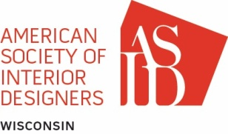

THE WISCONSIN CHAPTER OF ASID
BOARD MEETING MINUTES

Meeting Date: December 12, 2018
location | Skype conference
board members present | Bill Beaudreau, Michelle Kempen, Sarah Hansen, Jenny Hunt, Teresa Olson
meeting called by | Bill Beaudreau
call to order | 5:30 pm
AGENDA TOPICS

financial
MOTION
SECONDED
DISCUSSION | Jenny now has access to the BMO Harris accounts, has accessed the laptop, and has set up a meeting with Karen Johnson on Dec 19th
VOTE

MEMBERSHIP
MOTION
SECONDED
DISCUSSION | Discussion occurred about the next steps to replace Jenny Hunt as Membership Director. Candidate names were discussed and will be vetted, and asked if they would be willing to step into the role.
VOTE

SPONSORSHIP
MOTION
SECONDED
DISCUSSION | Ariel Steuer is working on updates to the sponsorship packages and will send out updates when they are ready for review.
VOTE

General topics needing discussion/resolution
MOTION
SECONDED

VOTE
DISCUSSION | - Discussion around new Membership Director  - Sarah Hansen, SRB, noted that the students may be interested in volunteering if it could be tied to scholarships. Is this viable?  - Next Board Meeting – January 2019. A Doodle poll will be issued to the board to confirm.

GUESTS IN ATTENDANCE | None

MEETING ADJOURNED | Meeting adjourned at 7:07 PM

